**HOW TO UNHIDE THE HIDDEN FOLDERS**

Go to folder and select the Options tap and uncheck all the hide option in View tab.

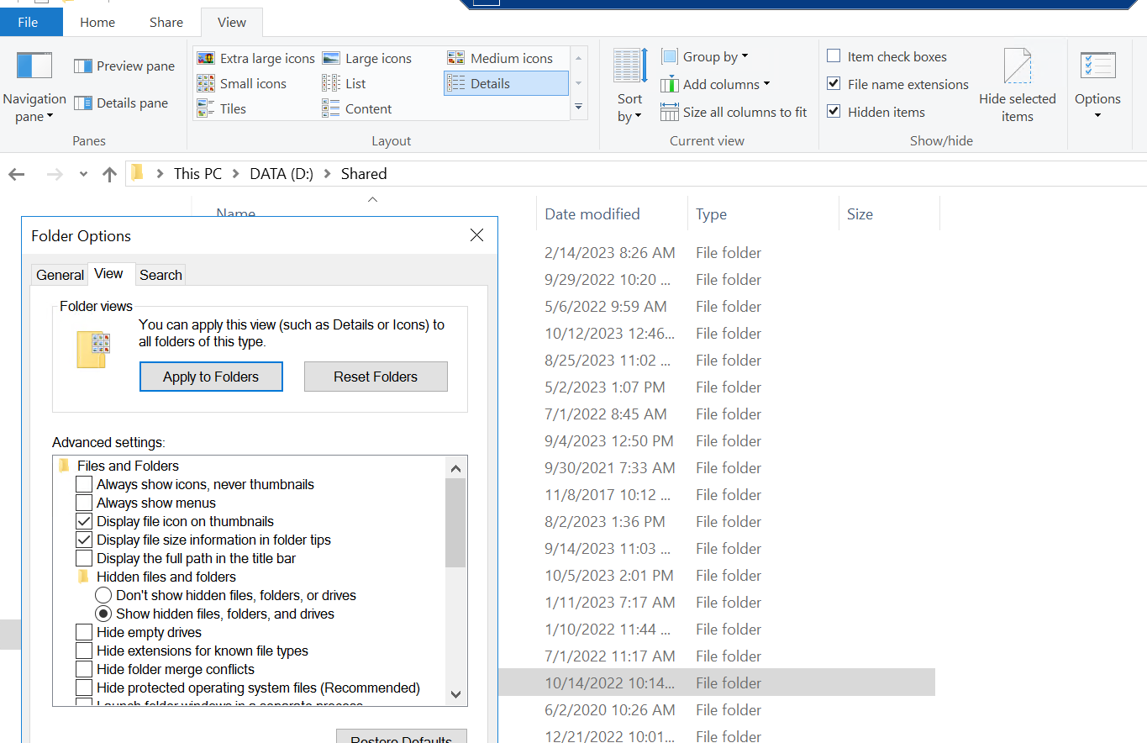

Step 2: Open the Command window. Run: **attrib -H -S -R <driveletter>:\file/folder path /S /D**

Step 3: Repeat for all sub-folders. Sub-folders may need to be run separately.

Step 3: Verify and exit. The folders will now be available and you may exit the Command window.

Refer to below link for the reference :-

Video Link : <https://youtu.be/fqE2SP9KxS0>